A Mini Project Synopsis on
ONLINE FOOD ORDERING SYSTEM

S.E. – Computer Science and Engineering-Data Science

Submitted By
Arya Patil 21107009
Harshal Patil 21107060
Tanvi Panchal 21107006
Rutuja Patil 21107012

Under The Guidance Of
Prof. Rajashri Chaudhari



DEPARTMENT OF CSE-DATA SCIENCE
A.P.SHAH INSTITUTE OF TECHNOLOGY
G.B. Road, Kasarvadavali, Thane (W), Mumbai-400615
UNIVERSITY OF MUMBAI

Academic year : 2022-23

CERTIFICATE

This to certify that the Mini Project report on Online Food Ordering System has been submitted by Arya Patil (21107009), Harshal Patil (21107060 ), Tanvi Panchal (21107006) and Rutuja Patil (21107012) who are a Bonafede students of A. P. Shah Institute of Technology, Thane, Mumbai, as a partial fulfilment of the requirement for the degree in Computer Science and Engineering(Data Science), during the academic year 2022-2023 in the satisfactory manner as per the curriculum laid down by University of Mumbai.

Ms. Prof. Rajashri Chaudhari
Guide

Prof. Anagha Aher Dr. Uttam D.Kolekar
Head Department of CSE-Data Science Principal

External Examiner(s)
1.
2.

Place: A. P. Shah Institute of Technology, Thane
Date:

TABLE OF CONTENTS

- Introduction.......................................................................................................... 1
  - Purpose..................................................................................................... 1
  - Objectives................................................................................................. 1
  - Scope........................................................................................................ 2
- Problem Definition………………….................................................................... 3
- Proposed System………....................................................................................... 4
  - Features and Functionality…………………………………………………..4
- Project Outcomes.................................................................................................. 7
- Software Requirements ........................................................................................ 8
- Project Design........................................................................................................9
- Project Scheduling..................................................................................................15
- Conclusion..............................................................................................................16

References
Acknowledgement
Project Scheduling Template
Sr. No | Group Member | Time duration | Work to be done
1 |  | 1st week of July | Implementing 1st module/ functionality (mention the name of module/ functionality at the place of 1st module/functionality)
1 |  | ^{1st} week of August | Testing 1st module  (mention the name of module/ functionality at the place of 1st module/functionality)
2 |  | 2nd week of August | Implementing 2nd module/ functionality (mention the name of module/ functionality at the place of 1st module/functionality)
3. |  | 3rd week of August
4. |  | …
 |  | By the end of September month | Implementing 3rd module/ functionality (mention the name of module/ functionality at the place of 1st module/functionality)

- INTRODUCTION:
Food Industry has always been a profitable industry not only for manufacturers, suppliers, but also for the users, distributers. The online food delivery system is the need of hour because of the recent changes in the industry and the increasing use of the internet. A Real-time online food ordering system for the customer is our proposed system.
Online Food Ordering System is a service which will help restaurants to optimized and 8control over their restaurants. This system helps the restaurants to do all functionalities more accurately and in faster ways also is supported to eliminate and in some cases reduce the hardships faced by the existing systems.
Also helps to maintain the stock and cash flow and there are many more functionalities, like: To store records, Control orders and services and No paper work thus provides digital billings.

  - PURPOSE
The purpose of Online Food Ordering System is to automate the existing manual system with the help of computerized equipments and full-fledged computer software, fulfilling their requirements, so that their valuable data/information can be stored for a longer period with easy accessing. This system allows the users to register, select food items from the menu and order food with just one click.

  - OBJECTIVE
The main objective of the Online Food Ordering System is to manage the details of item Category, Food, Delivery Address, Order, Shopping Cart. It manages all the information about item category, customer and other utilities like paying system and managing the specific outcomes based on customers outcomes. The project is totally built at a administration end and thus only the admin is guaranteed the access.

With a user-friendly interface, quick ordering features and easy checkout process, our system is designed to boost sales and conversions
Better Margins and High Average Cart Value are some of the benefits of the Online Food Ordering System
Online Food Ordering System is a efficient service that allows customers to directly place orders with desired restaurants.

  - SCOPE
The system will use Computerized Ordering System with the option of view a notification that the order has been received based on the requirement of the system. Orders received will go to inventory system monitor the products. The system will have the database that stores all the order information of the customer. Only the Administrator has an account on the system that can edit, modify, add, view menu and view reports, feedbacks, etc., that will be submitted by the customers.
The proposed system is a software solution for users to easily add and take orders. When the new orders come in, some general information about the new order will be inputted such as item from the menu, the price of each item, customer’s address, time and date.
The system is free from risk of possible file loss and will have backup files, so that the important data’s were safe. The system is also free from risk of being intercepted by unauthorized persons because before gaining access in the system, it is required to log onto the system by entering username and alphanumeric password.

- PROBLEM DEFINATION
The basic problem in the food service industry is not realizing efficiencies that would result from better applications of technology in their daily operations. Every restaurant has counter where you can place your order and then make the payment. So every restaurant needs an employee for taking the order and processing the payment.

Problem’s identified with the existing systems

Security Structure
System Back-up and System Restore
Corruption of database or any other file
Power failures/ loss

Our Online Food Ordering System will be equipped with a user-friendly touch screen, a credit/debit card reader, and software for completing the process at the backend. For this system there will be a system administrator who will have the rights to enter the menu with their current prevailing prices. He/she can enter anytime in the system by a secured system password to change the menu contents by adding or deleting an item or changing its price.
Now when the customer will open the system, he will place his order with the help of the touch screen using the intuitive graphical user interface, right from the selection of categories till the payment confirmation. He can select from his desired restaurants the food options according to his choice and the system will display the payment amount he has to make once he has finished with his order. The system will help to reduce the cost of labor and will be less probable to make mistake, since it’s a online food ordering system. Also the system will avoid long queues at the counters and will be available 24 hours.

- PROPOSED SYSTEM
The Online Food Ordering System performs different operation like: ordering, pricing & billing system. The customer input orders directly into the system which communicates the customer’s order to the customer’s desired restaurant’s kitchen and also the order data entry along with the total of purchase is displayed on the customer’s screen then directly the customer is redirected to the payment portal for purchasing the order. Once the payment is done the order gets confirmed by the restaurant and also a message for the same is received by the customer.

  - FEATURES AND FUNCTIONALITY
All users of the system, are required to first login to the accounts with their credentials and if a user is a new customer he is required to create a new account. This section lists the activity diagram and describes the flow of the activities in the system. A detailed description is given for each activity which provides an overview of the activity of the Online Food Order System.
- Customers of the Online Food Ordering system will interact with the application through an easy to use top navigation menu which includes the search option, user profile and view cart.
    - “Home” option : Allows the users to see all food items offered with nice images as well as select an item to place an order.
    - “Menu” option : A ‘Drop-Down’ menu, allows users to see all food items per category. Item can then be added to the cart using a single button click.
    - “Profile” option : User can view the account details like - name , mobile no., address , email id(optional). Also user is provided with the options of edit profile and delete account.
    - “My Cart” option :
- Allows users to see details of the items placed in cart. Details include Item , Product Name, Product Image, Product Description, Quantity, Unit Price, Total per item and final Total of the order. It also allows ‘Add’ and ‘Delete’ an item using single button click. User can then use a ‘Proceed to checkout’ button to proceed further.
- User will then be presented with a “Review Order” page, which will display Payment Information along with Order details to review. User can then use a ‘Check Out’ button to place an order.
- Once order is placed, user will be presented with appropriate Order confirmation success/failure message.

- Online Food Ordering System allows the Admin to access the system which provides Admin with below additional options under-
- “My Account” Drop down menu:
- Add Category: Allows to add a food Category name in a simple form.
- Add Product: Allows to add Product Name, Description, Price and choose Category along with Product Image.
- Modify Product: Allows updating or deleting product details.

- The system will automatically fetch new orders from the database at regular intervals and display the order numbers.
  - Under “My Account’ menu a customer will be able to see only his/her order whereas an Admin can see all users orders.
  - To view the details of an order, the user must click on that order number, which will display all order details. This structure can intuitively be expanded and collapsed to display only the desired information.

- The navigation bar also has a left side dashboard which provides the users with the following options-
      - Order history : This show items and billing history with date and time.
      - Feedback : Select your order with the help of order id/No. and submit feedback for that order.
      - Contact us : It provides the customer with the contact details like toll-free no. email address, etc.
      - Terms and Conditions : For Online Food Ordering System this section is necessary, which helps the user to go through all the terms and conditions regarding their orders and also provides the overall system analysis.

- Delivery Orders : It provides the customer with all the details regarding their order and delivery status.
- Modify/Cancel Order : For cancellation or modification of an order, the user can view all the policies of the system for the same.
- Delivery Charges : Delivery charges are added to the bill of the customer according to the customer’s delivery address.
- Information Security : Customer can go through all the safety precautions mentioned that are taken by the delivery in charge.
- Cooking Goodness : This section gives a quick glance of the trusted brands from which the products are taken to prepare the order and assurance of providing he correct order.

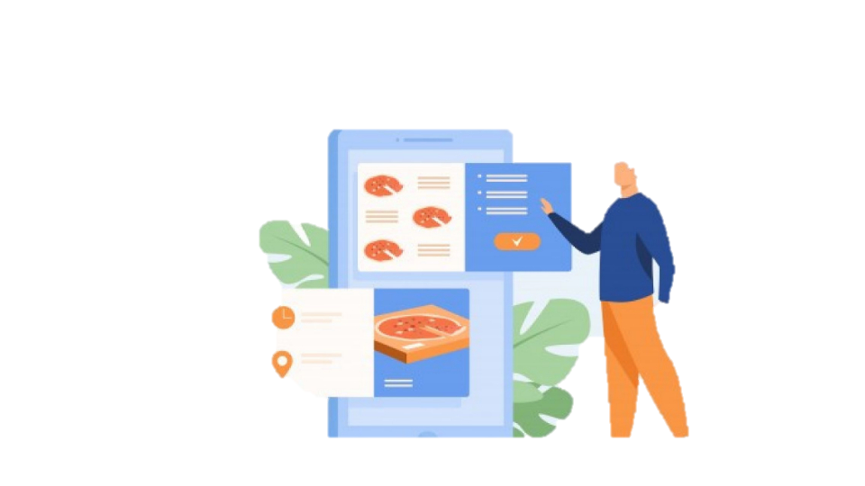

Online Food Menu
Place Food Order
Order In Process
Order Delivered to Location


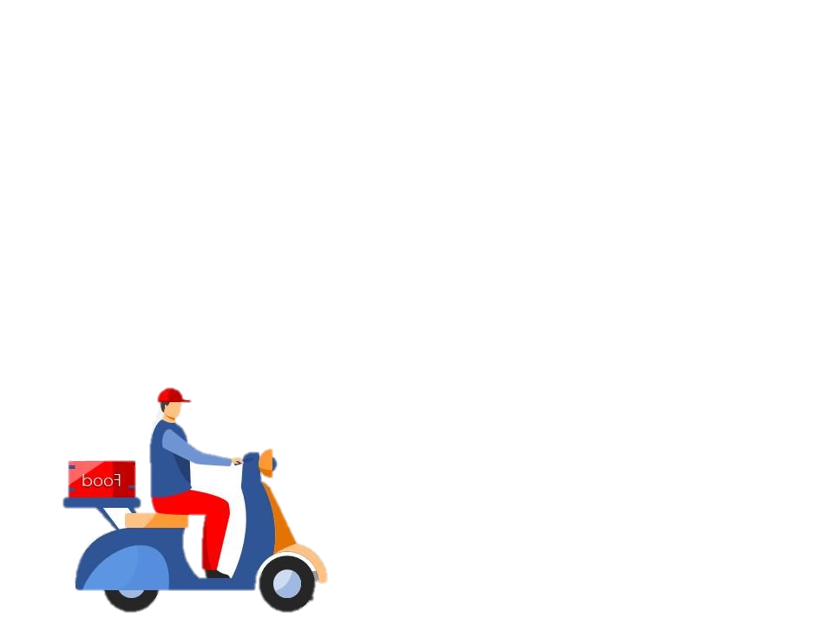


Find Restaurant
Payment By User
Delivery Service

  - OUTCOMES
  - It can be done by making the ordering process convenient for them. Eventually, this “convenience” will pay huge dividends for your restaurant. One thing is certain that people don’t like to order their food over the phone. Everyone wants to place their order without fuss and undoubtedly, asap.
  - During the rush hour, they can place the order online and pick up their food from the restaurant at a set time. In this way, they don’t wait in long lines.
  - When you have an online ordering system for your restaurant, you amplify your web presence because you can receive orders from your website/facebook page/mobile app directly to the kitchen.
  - A good online ordering system will have an inbuilt analytics platform that will help you to track this data and channel it to sell better.
  - When customers order online, there are fewer distractions. They don’t have to decide quickly on the items as there is no-one waiting to take the order.
  - Online ordering platforms are inbuilt for cross-selling items. As they spend more time on the menu, they order appetizers that they wouldn’t order in the store. Add-On items in the menu see better sales, online.
  - Your online ordering system also takes care of your margins. Since your restaurant’s orders don’t go through a third party platform, you will notice a change in your operating margins.
  - With online ordering on board you will enrichen your customer experience by making the process of ‘placing orders’ a lot easier. It will show that you value your customer’s time.
  - Online ordering will boost your productivity by eliminating the inefficient process of taking orders. It will help you to plan and implement an adaptive marketing campaign.
  - Can be useful to people who are more comfortable with online ordering, rather than stepping into the traditional stores for the services.

  - SOFTWARE REQUIREMENTS

The Software Requirements Specification is produced at the culmination of the
analysis task. The function and performance allocated to software as part or system
engineering are refined by establishing a complete information description, a detailed
functional and behavioral description, an indication of performance requirements and design
constraints, appropriate validation criteria, and other data pertinent to requirements.

- The proposed system has the following requirements:

- System needs store information about new entry of Food Item.

- System needs to help the internal staff to keep information of Category and find
them as per various queries

- System need to maintain quantity record.

- System need to keep the record of Customer.

- System need to update and delete the record.

- System also needs a search area.

- It also needs a security system to prevent data

Name of component | Specification
Operating system | Windows 10, Windows 11
Language | Java SE Runtime Environment
Database | MySQL Server
Browser | Chrome, Microsoft Edge, etc
Software Development Kit | Java JDK 18.0.1
Scripting Language Enable | JSP (Java Server Pages)
Database JDBC Driver | MySQL Jconnector
  - PROJECT DESIGN
In this phase, a logical system is built which fulfils the given requirements. Design phase of software development deals with transforming the user’s requirements into a logically working system. Normally, design is performed in the following in the following two steps:

- Primary Design Phase: In this phase, the system is designed at block level. The blocks are created on the basis of analysis done in the problem identification phase. Different blocks are created for different functions emphasis is put on minimizing the information flow between blocks. Thus, all activities which require more interaction are kept in one block.

- Secondary Design Phase: In the secondary phase the detailed design of every block is performed. The general tasks involved in the design process are the following:

- Design various blocks for overall system processes

- Design smaller, compact and workable modules in each block

- Design various database structures.

- Specify details of programs to achieve desired functionality

- Design the form of inputs, and outputs of the system.

- Perform documentation of the design.

- System reviews.

SYSTEM DESIGN AND IMPLEMENTATION

6.1 DESIGN STANDARD

The system is designed with several interaction cues on each page that makes up the Online Food Ordering System. These cues are well-defined such as to make several functionality that the system exposes to collect, process and output data. Access to these functionalities is made possible by the well designed user interface which embodies several technologies to process data. The system is built in a modular form where these functionalities are built into modules. Some of the modules are as follows:

- Cart

- Check login

- Category details

- Feedback/Suggestions

6.2 OUTPUT SPECIFICATION

The system is designed in such a way that it efficiently provides output to the user promptly and in a well organized manner. The format for the several output are made available on the output pages. Output can be relayed using the following page modules:

      - Product list: This display output information for the list of food delicacies which are currently available
      - Order history : This shows items and billing history with date and time.
      - Feedback : Select your order with the help of order id/No. and submit feedback for that order.
      - Contact us : It provides the customer with the contact details like toll-free no. email address, etc.
      - Terms and Conditions : For Online Food Ordering System this section is necessary, which helps the user to go through all the terms and conditions regarding their orders and also provides the overall system analysis.

6.3 INPUT SPECIFICATION
The system is designed to accept several input details efficiently through input forms and user clicks. The data captured through the user keystrokes and clicks are received by specific modules on the system and relayed to the back-end of the system for processing. Input is collected using the following page modules:

- User Profile : This is used to view the account details like - name , mobile no., address , email id(optional). Also user is provided with the options of edit profile and delete account.

- Admin login: This is used to capture information about the administrative personnel who controls content and display on the system.

6.4 DATABASE SPECIFICATION
The database system used to implement the back-end of the Online Food Ordering System is MySQL. Access to the system was made possible by a graphical interface (Netbeans) with Java JDK Packages. The database name is SQL Schemas and the structure of the data tables in the database are as follows:

1. Admin

2. Products

ADMIN
Allows to add and Product Name, Description, Price and choose Category along with Product Image.

FIELD | TYPE | LENGTH
Id | Int | 11
Username | varchar | 24
Password | varchar | 24
Last Log In Date | Date

PRODUCTS
Allows to add Product Name, Description, Price and choose Category along with Product Image.
FIELD | TYPE | LENGTH
Id | Int | 11
Product Name | varchar | 16
Price | varchar | 16
Details | varchar | 200
Category | varchar | 16

6.5 MAIN DESIGN
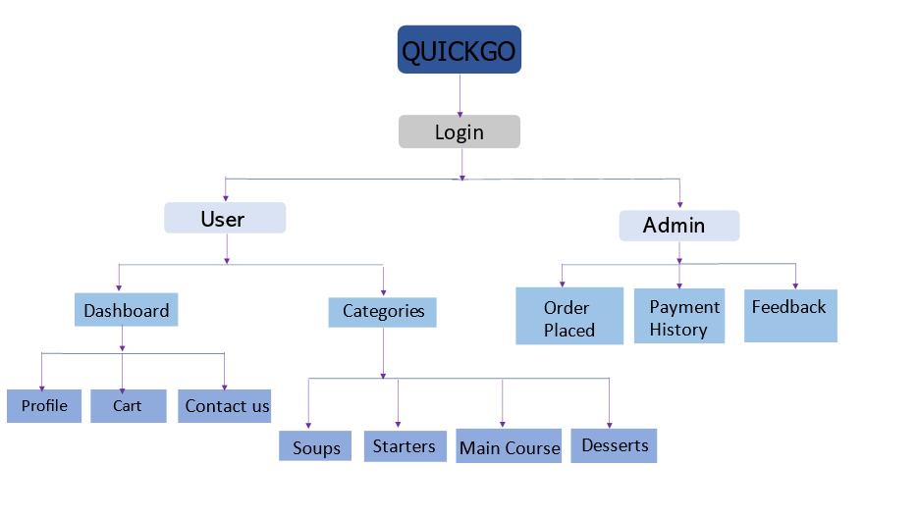

6.6 PROGRAMMING LANGUAGE
So many programming languages were put into consideration in the cause of designing this software. A lot of factors were also considered which includes the online database access, data transmission via networks, online database retrieval, online data capture, multi user network access database security, etc. The database system used to implement the back-end of this system is MySQL. MySQL database is a robust database that can guarantee database integrity, database protection and accommodate large database. The database system used to implement the back-end of the Online Food Ordering System is MySQL. Access to the system was made possible by a graphical interface (Netbeans) with Java JDK Packages. The database name is SQL Schemas. Netbeans is very user friendly and can be modified programmatically.

6.7 SYSTEM REQUIREMENTS
Computer system is made up of units that are put together to work as one in order to achieve a common goal. For the effective implementation of the new system, the following software has to be installed on the computer

- Windows 10, Windows 11

- MySQL

- Java JDK 18.0.1

- NetBeans

  - PROGRAM FLOWCHART

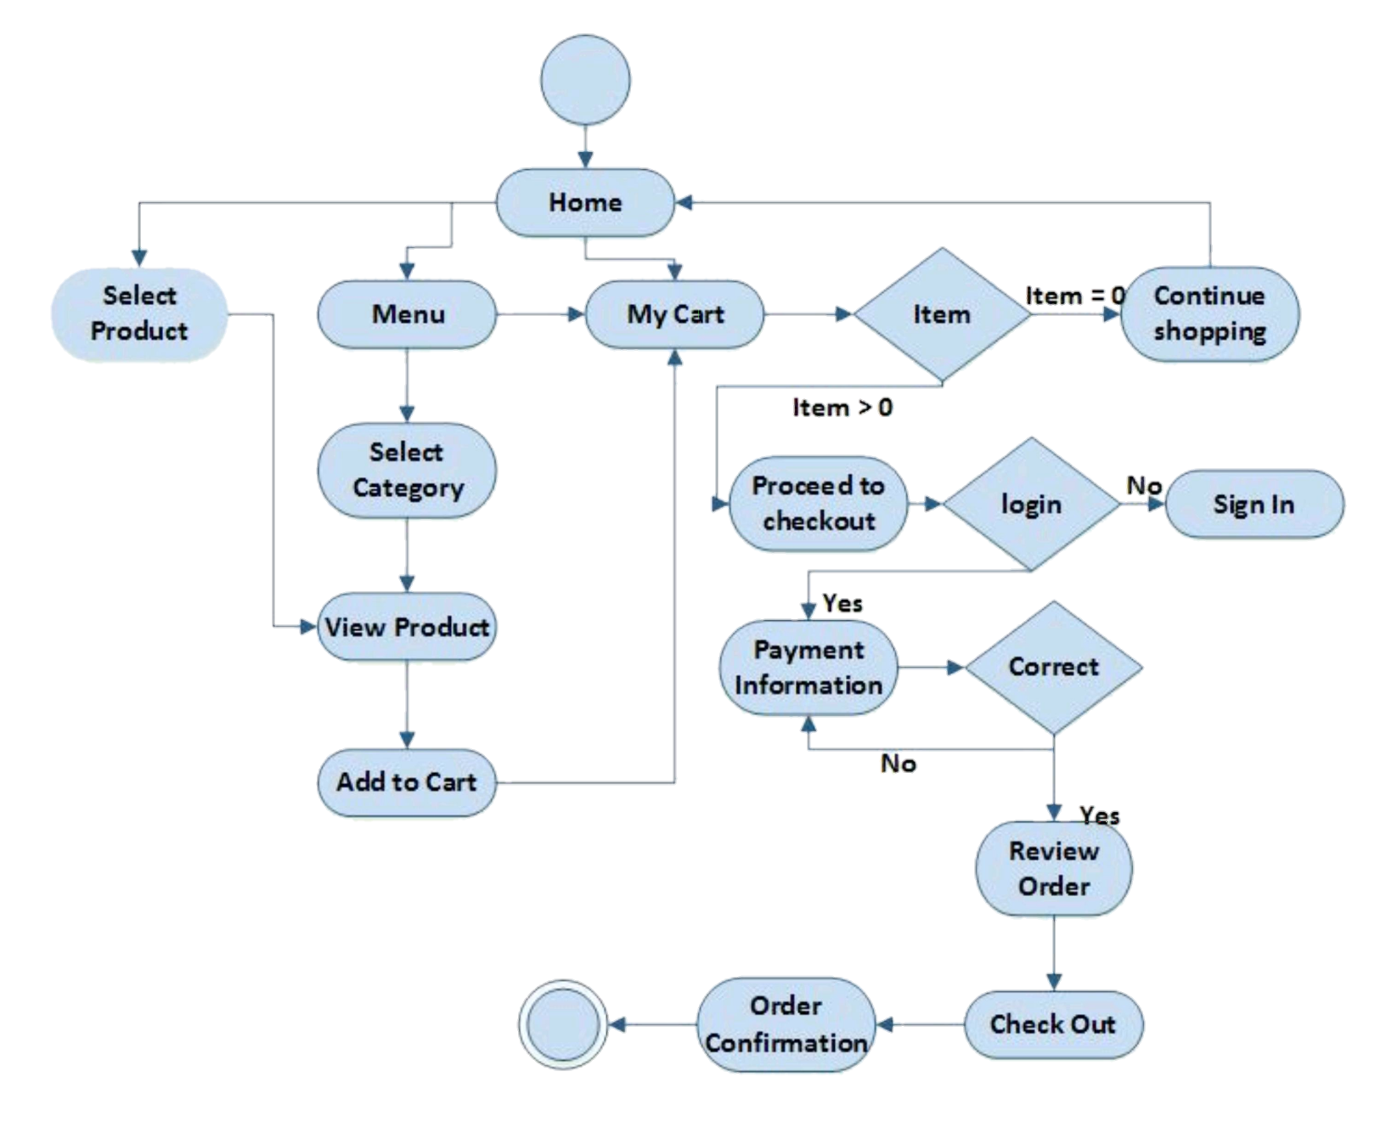
  - PROJECT SCHEDULING
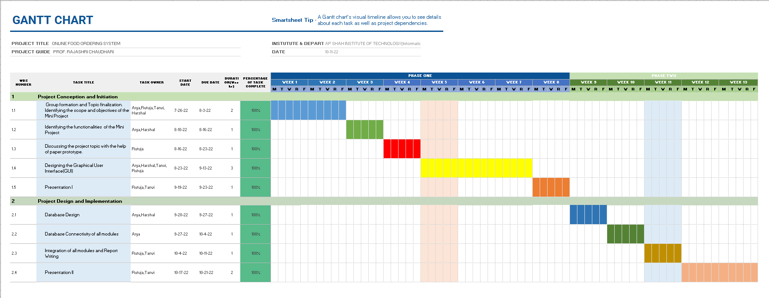
  - CONCLUSION
The development of online food ordering system involved many phases. The approach used is a top-down one concentrating on what first, then how and moving to successive levels of details.
The first phase started with a detailed study of the problems and prospects of Online Food Ordering System. In the course of this study. many problems were discovered to have hindered the effectiveness of the existing manual system. These problems, information needs and activities were documented and later used as the basis for system design, which immediately followed the first phase. The design phase was concerned primarily with the specification of the system elements in manner that best met the organization's business needs. During this phase, strict adherence was made on proven software engineering principles and practices. To implement this design, a computer program was then written and tested in NetBeans environment. It is hoped that effective implementation of this software product would eliminate many problems discovered during systems investigation.

At the end it is concluded that we have made effort on following points:

1. A description of the background and context of the project and its relation to work already done in the area.

- Made statement of the aims and objectives of the project.

- The description of Purpose, Scope, and applicability.

- We define the problem on which we are working in the project

- We describe the requirement Specifications of the system and the actions that can be done on these things.

- We understand the problem domain and produce a model of the system, which describes operations that can be performed on the system.

- We included features and operations in detail, including screen layouts.

- We designed user interface and security issues related to system.

- Finally the system is implemented and tested according to test cases.

